Heart Simulator User Guide
Starting Up
To run the simulator, run the class Simulator from within your IDE or at the command line with the command java Simulator.
When the simulator launches, a simulation will automatically begin running with default values.
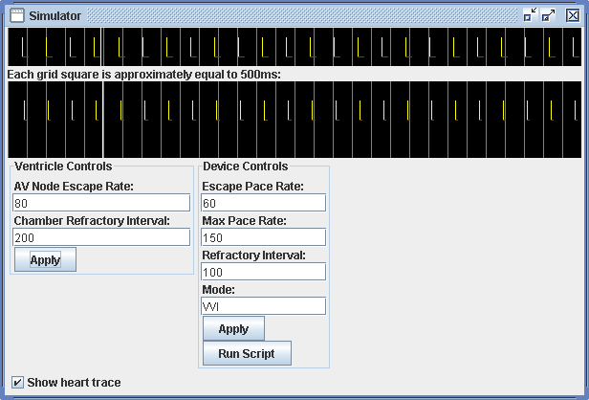
Understanding The Simulation
Figure 1

The simulator window is divided into three main sections, described in detail below:
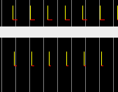
Trace
Normal rythym
The trace shows activity generated by the simulation. The upper portion shows activity directly from the heart.
Key:
- Yellow vertical lines show heart beats.
- Red horizontal lines indicate the heart is in refractory period; during this period it will not respond to attempts to beat again.
The lower portion shows information being sent by the device monitoring the heart.
Key:
- Yellow vertical lines show heart beats sensed by the device.
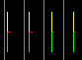
- Red horizontal lines indicate the device is in refractory period; during this period it will not respond to further beats sensed.
Escape Pacing
- Green vertical lines indicate that the device has sent an Escape Pace to the heart.
- Red vertical lines indicate that the device has paced the heart at the shortest interval allowed by the device's Maximum Pacing Rate.
- White vertical lines indicate that the device has responded to an intrinsic heart beat with a Triggered Pace.
The white scrolling line indicates where the trace is currently being redrawn; gray vertical lines are for reference only. They are drawn on the screen at intervals that approximate 500 milliseconds.
Ventricle Controls
The controls in this panel allow the user to adjust the settings of the heart chamber (a ventricle).
Settings:
- AV Node Escape Rate: this is the rate in Beats Per Minute (BPM) at which the ventricle will automatically beat. The timer measuring this rate is automatically reset any time the chamber beats, either on its own or via a pace from the device.
- Chamber Refractory Interval: specified in milliseconds (ms). The refractory interval is entered automatically any time the chamber beats; during this interval, the chamber will not respond to beat reqeusts from any source.
To change settings, enter the desired values and click the Apply button.
Device Controls
The controls in this panel allow the user to adjust the settings of the device.
Settings:
- Escape Pace Rate: this is the lower rate in (BPM) at which the device will pace the heart chamber. Any time the heart rate falls below this rate, the device will send an Escape Pace to the heart. The timer measuring this rate is automatically reset any time the chamber beats
- Max Pace Rate: this is the maximum rate at which the device will pace the heart. Any pace events at a rate greater than the Max Pace Rate will automatically be throttled to this rate.
- Refractory Interval: specified in milliseconds (ms). The refractory interval is entered automatically any time the device senses a beat, either via a pace or intrinsic. During this interval, the device will ignore any additional beats.
- Mode: this specifies the mode in which the device is operating.
Valid modes:
VOO: in this mode, the device does not sense any events from the heart and will therefore pace at the device escape rate.
VVI: in this mode, the device will monitor heart beats and only pace when the heart rate drops below the device escape rate.
VVT: a diagnostic mode, in which the device functions as in VVI, but will also generate a triggered pace whenever a beat from the heart is sensed.
To change settings, enter the desired values and click the Apply button.
- Run Script: clicking this button will display a dialog box which will allow the user to navigate the file system and select a script file to run. Upon selecting a script, it will automatically run. Output will be displayed in the console window as well as being reflected in the output on the trace display.
Scripting
The following actions can be performed via the script:
- The device pacing rate can be changed via the rateRule. The syntax for rateRule is:

Format: rate value
Example: rate 60 or RATE 60

- The refractory period of the device can be changed via the refractoryRule. The syntax for refractoryRule is:

Format: refractory value
Example: ref 200 or REF 200

- The mode can be changed via the modeRule. The syntax for modeRule is:

Format: mode type
type: VOO | VVI | VVT | AOO | AAI | AAT | DDD
Example: mode VVI or MODE vvi

- The AV delay can be changed via the avdRule. The syntax for avdRule is:

Format: avd value
Example: avd 200 or AVD 200

- The atrium or ventricle can be sensed or paced the ‘count’ number of times via the countRule. The syntax for countRule is:

Format: count channelaction value
Example: count vs 6 or COUNT AP 4

- An amount of wait time can be specified between blocks of script via the waitRule. The syntax for waitRule is:

Format: wait value
Example: wait 4000 or WAIT 4000

- Single-line comments followed by two slashes can be given in the script via the commentRule, which prints the comment. The syntax for commentRule is:

Format: //comment
Example: //This is a single-line comment

- Multiple line comments also can be given in a script. The lexer just ignores them. The syntax for multiple-line comments is:

Format: /* multiple
line
comments */
Example: /* This is a
multiple-line comment */

